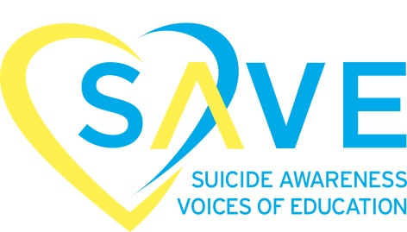

2020 Sponsorship Opportunities
Speak Up and SAVE

VIP Event Sponsor $5,000
- Recognition as Event Sponsor and inclusion in event name
- Visual recognition including corporate logo placed alongside the SAVE logo on the photobooth backdrop
- VIP reserved table with 8 tickets to the event
- Visual recognition including corporate logo prominently placed on all printed materials including all social media
- Prominent signage on SAVE’s event registration site
- Verbal acknowledgement during event program
- Opportunity to showcase product or marketing materials
- Opportunity to welcome or speak at the event

Platinum Sponsor $3,000
- Presentation of Hands of Hope Banner at the event
- Visual recognition including corporate logo prominently placed on all printed materials including all social media
- Prominent signage on SAVE’s event registration site
- Verbal acknowledgement during event program
- Opportunity to showcase product or marketing materials
- 6 tickets into the event

Gold Sponsor $1,500
- Visual recognition including corporate logo prominently placed on all printed materials including all social media
- Prominent signage on SAVE’s event registration site
- Verbal acknowledgement during event program
- 4 tickets into the event

Silver Sponsor $750
- Visual recognition including corporate logo prominently placed on all printed materials including all social media
- Prominent signage on SAVE’s event registration site
- Verbal acknowledgement during event program
- 2 tickets into the event

Alcohol Sponsor
This includes donating any type of alcohol to the event
- Visual recognition including corporate logo prominently placed near all the bars and alcohol at the event
- Prominent signage on SAVE’s event registration site

Food Sponsor
This includes donating any type of food / food station to the event
- Visual recognition including corporate logo prominently placed near all the food stations at the event
- Prominent signage on SAVE’s event registration site

Dessert Sponsor
This includes donating any type of dessert to the event
- Visual recognition including corporate logo prominently placed near all the dessert station at the event
- Prominent signage on SAVE’s event registration site

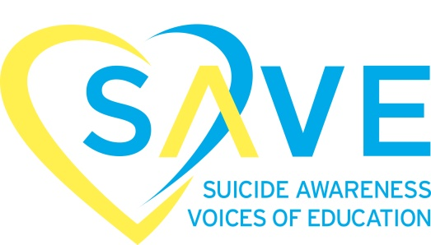

Please indicate below the type of sponsorship you will support and complete the additional information requested below. Completed applications can be mailed or faxed to the following:

Speak Up and SAVE – Chicago, IL 2020
8120 Penn Ave. South #470
Bloomington, MN 55431
Linda Lurie Mars – SAVE National Outreach Network and Event Coordinator
Email: lmars@save.org
Office: 952-946-7998
Fax: 952-829-0841

Type of Sponsorship:
VIP Event Sponsor $5,000
Platinum Sponsor $3,000
Gold Sponsor $1,500
- Silver Sponsor $750
- Alcohol Sponsor
- Food Sponsor
- Dessert Sponsor

Corporation Name: __________________________________________________

Address: ___________________________________________________________________________

City/State/Zip _____________________________________________________________________

Phone: _____________________________________________________________________________

Email: _____________________________________________________________

Signature and Date:

______________________________________________Date:_____________________

